

**AROR UNIVERSITY OF ART ARCHITECTUR DESIGN AND HERITAGE SUKKUR**

**Lab 04**

**TASK 01**

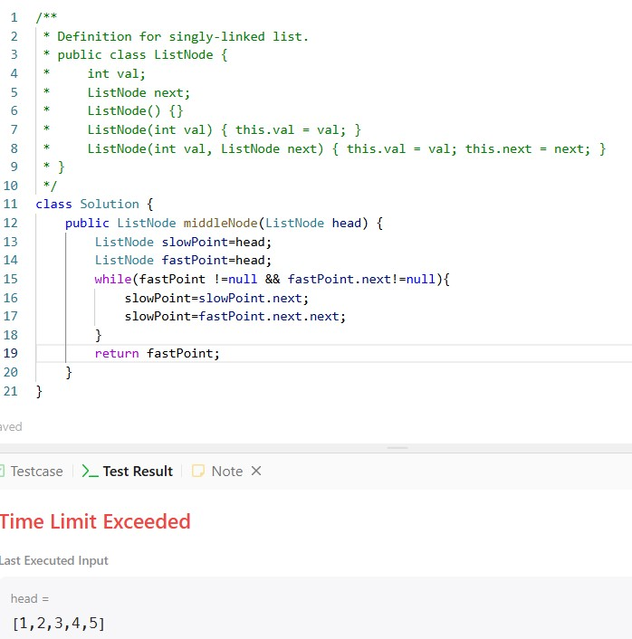

**TASK 02**

**yum**

**TASK 03**

